Objective Questions

- List the different dtypes of columns in table “ball_by_ball” (using information schema)
Code:
SELECT column_name, data_type
FROM information_schema.columns
WHERE table_name = 'ball_by_ball';
Output:
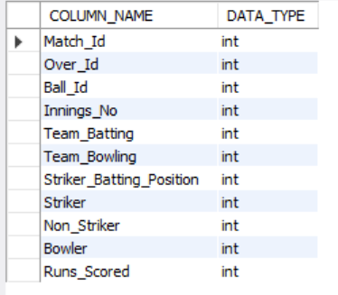
Answer Explanation
- Match_Id – identifies the match
- Over_Id – identifies the over
- Ball_Id – identifies the ball
- Innings_No – innings number
- Team_Batting / Team_Bowling – teams involved
- Striker / Non_Striker – batsmen
- Bowler-who bowls the ball
- Runs_Scored – runs scored on that ball

- What is the total number of runs scored in 1st season by RCB (bonus: also include the extra runs using the extra runs table)

Code:
SELECT
SUM(b.Runs_Scored) + COALESCE(SUM(e.Extra_Runs), 0) AS Total_Runs
FROM ball_by_ball b
JOIN matches m
ON b.Match_Id = m.Match_Id
JOIN Team t
ON b.Team_Batting = t.Team_Id
LEFT JOIN extra_runs e
ON b.Match_Id = e.Match_Id
AND b.Over_Id = e.Over_Id
AND b.Ball_Id = e.Ball_Id
AND b.Innings_No = e.Innings_No
WHERE t.Team_Name = 'Royal Challengers Bangalore'
AND m.Season_Id = (
SELECT MIN(Season_Id)
FROM matches
);
Output:
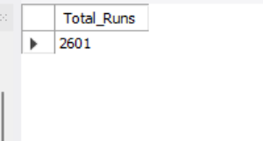

Answer Explanation:
The analysis calculates RCB’s total runs in the 1st IPL season, combining batsman runs with extra runs. This provides a complete view of RCB’s scoring performance and can be used as a baseline for comparing their performance in later seasons.

- How many players were more than the age of 25 during season 2014?

Code:
SELECT
'2014' AS Season,
COUNT(DISTINCT p.Player_Id) AS Player_Count
FROM player p
JOIN player_match pm
ON p.Player_Id = pm.Player_Id
JOIN matches m
ON pm.Match_Id = m.Match_Id
JOIN season s
ON m.Season_Id = s.Season_Id
WHERE s.Season_Year = 2014
AND TIMESTAMPDIFF(YEAR, p.DOB, '2014-04-01') > 25;

Output:


Visual chart:

Answer Explanation:
I joined the player, player_match, matches, and season tables, filtered for 2014, calculated the players' ages using their DOB, and counted distinct players older than 25 and the result: 90 players.

- How many matches did RCB win in 2013?

CODE:

SELECT COUNT(*) AS Matches_won_in_2013
FROM matches m JOIN season s
ON m.Season_Id=s.Season_Id
WHERE s.Season_Year=2013
AND m.Match_Winner=2;

Output:


Answer explanation:
The query counts the number of matches RCB won in the 2013 season. It filters the matches for Season 6 (2013) and RCB as the winner, resulting in 9 matches won.

- List the top 10 players according to their strike rate in the last 4 seasons

Code:
SELECT
p.Player_Name,
ROUND((SUM(bb.Runs_Scored) * 100.0) / COUNT(bb.Ball_Id), 2) AS Strike_Rate
FROM player p
JOIN ball_by_ball bb
ON p.Player_Id = bb.Striker
JOIN matches m
ON bb.Match_Id = m.Match_Id
JOIN season s
ON m.Season_Id = s.Season_Id
WHERE s.Season_Year BETWEEN 2014 AND 2017
GROUP BY p.Player_Id, p.Player_Name
ORDER BY Strike_Rate DESC
LIMIT 10;

Output:
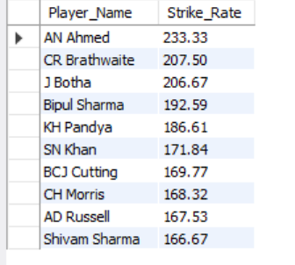

Visual chart:

- What are the average runs scored by each batsman considering all the seasons?

Code:
SELECT
p.Player_Name,
AVG(bb.Runs_Scored) AS Average_Runs
FROM player p
JOIN ball_by_ball bb
ON p.Player_Id = bb.Striker
GROUP BY p.Player_Id, p.Player_Name;

Output:
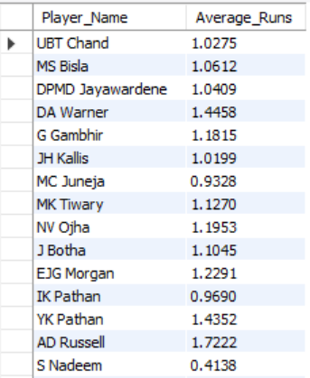

Visual chart:

Answer explanation:
This query calculates the average runs scored by each batsman across all IPL seasons. It joins the player and ball_by_ball tables using Player_Id and Striker, then uses AVG(Runs_Scored) to find each batsman’s average runs.

- What are the average wickets taken by each bowler considering all the seasons?

Code:
SELECT
p.Player_Id,
p.Player_Name,
ROUND(COUNT(w.Match_Id) * 1.0 / COUNT(DISTINCT bb.Match_Id), 2) AS Avg_Wickets_Per_Match
FROM player p
JOIN ball_by_ball bb
ON p.Player_Id = bb.Bowler
LEFT JOIN wicket_taken w
ON bb.Match_Id = w.Match_Id
AND bb.Over_Id = w.Over_Id
AND bb.Ball_Id = w.Ball_Id
AND bb.Innings_No = w.Innings_No
AND w.Kind_Out NOT IN (3, 5, 6)
GROUP BY p.Player_Id, p.Player_Name
ORDER BY Avg_Wickets_Per_Match DESC;

Output:
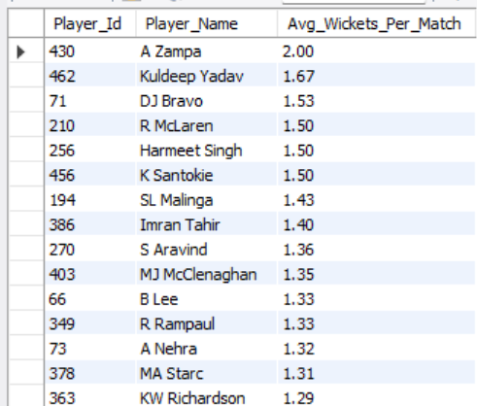

Visual chart:

Answer explanation:
This query calculates each bowler's average wickets per match across all IPL seasons. It joins ball_by_ball (every delivery bowled) with wicket_taken (matched exactly on match, over, ball, and innings) to correctly attribute wickets to the bowler of that specific delivery. It excludes dismissal types not credited to the bowler — like run-outs — using Kind_Out NOT IN (3, 5, 6). Total wickets are counted from matched rows, and total matches bowled are counted as distinct matches per player. Dividing wickets by matches bowled gives the average, rounded to 2 decimals. Results are sorted in descending order, so bowlers with the highest average wickets per match appear first. This effectively ranks bowlers by consistency and strike-taking ability over their careers.

- List all the players who have average runs scored greater than the overall average and who have taken wickets greater than the overall average

Code:
WITH batting_avg AS (
SELECT
p.Player_Id,
p.Player_Name,
AVG(bb.Runs_Scored) AS Avg_Runs
FROM player p
JOIN ball_by_ball bb
ON p.Player_Id = bb.Striker
GROUP BY p.Player_Id, p.Player_Name
),
bowling_wkts AS (
SELECT
p.Player_Id,
COUNT(w.Match_Id) AS Total_Wickets
FROM player p
JOIN ball_by_ball bb
ON p.Player_Id = bb.Bowler
LEFT JOIN wicket_taken w
ON bb.Match_Id = w.Match_Id
AND bb.Over_Id = w.Over_Id
AND bb.Ball_Id = w.Ball_Id
AND bb.Innings_No = w.Innings_No
AND w.Kind_Out NOT IN (3, 5, 6)
GROUP BY p.Player_Id
)
SELECT
ba.Player_Name,
ba.Avg_Runs,
bw.Total_Wickets
FROM batting_avg ba
JOIN bowling_wkts bw
ON ba.Player_Id = bw.Player_Id
WHERE ba.Avg_Runs > (SELECT AVG(Avg_Runs) FROM batting_avg)
AND bw.Total_Wickets > (SELECT AVG(Total_Wickets) FROM bowling_wkts)
ORDER BY ba.Avg_Runs DESC, bw.Total_Wickets DESC;

Output:
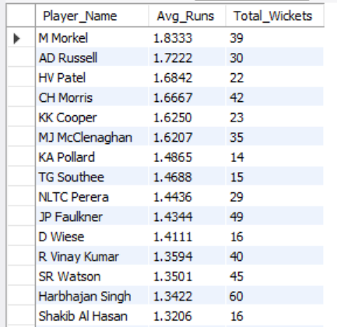
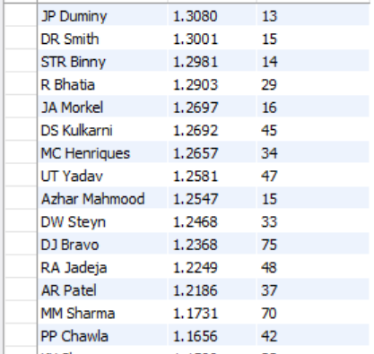
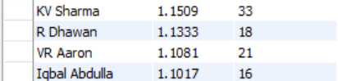

Visual chart:

Answer explanation:
This query identifies all-rounders — players whose batting average and bowling wicket count both exceed the league-wide averages. It uses two CTEs: batting_avg computes each player's average runs per ball faced, and bowling_wkts computes each player's total wickets (excluding non-bowler dismissals like run-outs). The main query joins these two on Player_Id, then filters to only players whose Avg_Runs beats the overall average of Avg_Runs (across all batsmen) and whose Total_Wickets beats the overall average of Total_Wickets (across all bowlers). The result is sorted by batting average, then wickets, both descending, so the strongest dual-threat players appear first.

- Create a table rcb_record table that shows the wins and losses of RCB in an individual venue.

Code:
CREATE TABLE rcb_record AS
SELECT
v.Venue_Id,
v.Venue_Name,
SUM(CASE WHEN m.Match_Winner = 2 THEN 1 ELSE 0 END) AS Wins,
SUM(CASE WHEN m.Match_Winner <> 2 THEN 1 ELSE 0 END) AS Losses,
COUNT(*) AS Total_Matches
FROM matches m
JOIN venue v
ON m.Venue_Id = v.Venue_Id
WHERE m.Team_1 = 2 OR m.Team_2 = 2
GROUP BY v.Venue_Id, v.Venue_Name
ORDER BY Wins DESC;
select * from rcb_record;
output:
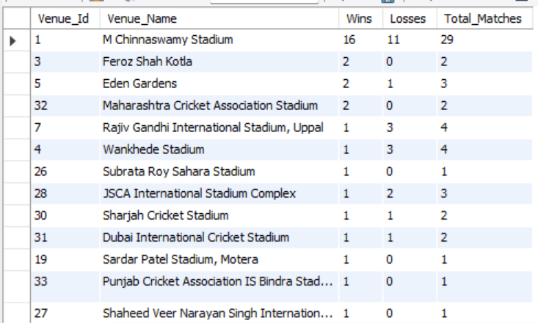
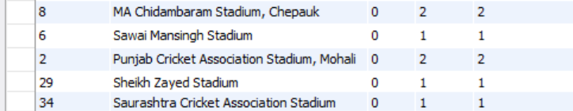

Answer explanation:
This creates a new table, rcb_record, that shows RCB's (Team_Id = 2) win-loss record broken down by venue. It filters matches to only games RCB played (as Team_1 or Team_2), joins to venue for venue names, then counts wins (where Match_Winner = 2) and losses (where the winner wasn't RCB) per venue using CASE expressions inside SUM. Total_Matches gives the overall count played at each venue. Results are grouped by venue and sorted by most wins first, giving a quick view of where RCB performs best or worst.

- What is the impact of bowling style on wickets taken?

Code:
SELECT
bs.Bowling_Skill,
COUNT(w.Match_Id) AS Total_Wickets
FROM player p
JOIN bowling_style bs
ON p.Bowling_skill = bs.Bowling_Id
JOIN ball_by_ball bb
ON p.Player_Id = bb.Bowler
LEFT JOIN wicket_taken w
ON bb.Match_Id = w.Match_Id
AND bb.Over_Id = w.Over_Id
AND bb.Ball_Id = w.Ball_Id
AND bb.Innings_No = w.Innings_No
AND w.Kind_Out NOT IN (3, 5, 6)
GROUP BY bs.Bowling_Skill
ORDER BY Total_Wickets DESC;

Output:
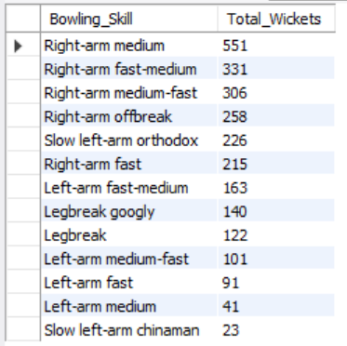

Visual chart:

Answer explanation:
This query counts total wickets grouped by bowling style. It starts from player, joins to bowling_style to get the style label (e.g. right-arm fast, leg-spin), then joins to ball_by_ball to get every delivery bowled by players of that style. It then LEFT JOINs wicket_taken, matching exactly on match, over, ball, and innings — so a wicket is only attached to a delivery if one actually fell on it. The condition Kind_Out NOT IN (3, 5, 6) excludes dismissal types not credited to the bowler, such as run-outs. COUNT(w.Match_Id) then counts only the deliveries where a valid, bowler-credited wicket occurred, giving the total wickets per bowling style. Grouping by Bowling_Skill aggregates this across all bowlers who share that style, and the results are sorted in descending order so the most productive bowling styles appear first.

- Write the SQL query to provide a status of whether the performance of the team is better than the previous year's performance on the basis of the number of runs scored by the team in the season and the number of wickets taken
Code:
WITH team_runs AS
(
SELECT
m.Season_Id,
b.Team_Batting AS Team_Id,
SUM(b.Runs_Scored) AS Runs_Scored
FROM Ball_by_Ball b
JOIN Matches m
ON b.Match_Id = m.Match_Id
GROUP BY
m.Season_Id,
b.Team_Batting
),

team_wickets AS
(
SELECT
m.Season_Id,
b.Team_Bowling AS Team_Id,
COUNT(w.Player_Out) AS Wickets_Taken
FROM Wicket_Taken w
JOIN Ball_by_Ball b
ON w.Match_Id = b.Match_Id
AND w.Over_Id = b.Over_Id
AND w.Ball_Id = b.Ball_Id
AND w.Innings_No = b.Innings_No
JOIN Matches m
ON b.Match_Id = m.Match_Id
WHERE w.Kind_Out IN (1, 2, 4, 6, 7, 8)
GROUP BY
m.Season_Id,
b.Team_Bowling
),

team_performance AS
(
SELECT
s.Season_Year,
t.Team_Id,
t.Team_Name,
COALESCE(tr.Runs_Scored, 0) AS Runs_Scored,
COALESCE(tw.Wickets_Taken, 0) AS Wickets_Taken
FROM team_runs tr
JOIN Team t
ON tr.Team_Id = t.Team_Id
JOIN Season s
ON tr.Season_Id = s.Season_Id
LEFT JOIN team_wickets tw
ON tr.Season_Id = tw.Season_Id
AND tr.Team_Id = tw.Team_Id
),

comparison AS
(
SELECT
*,
LAG(Runs_Scored) OVER
(
PARTITION BY Team_Id
ORDER BY Season_Year
) AS Previous_Runs,

LAG(Wickets_Taken) OVER
(
PARTITION BY Team_Id
ORDER BY Season_Year
) AS Previous_Wickets
FROM team_performance
)

SELECT
Team_Name,
Season_Year,
Runs_Scored,
Previous_Runs,
Wickets_Taken,
Previous_Wickets,

CASE
WHEN Previous_Runs IS NULL
OR Previous_Wickets IS NULL
THEN 'No Previous Season'

WHEN Runs_Scored > Previous_Runs
AND Wickets_Taken > Previous_Wickets
THEN 'Better'

WHEN Runs_Scored < Previous_Runs
AND Wickets_Taken < Previous_Wickets
THEN 'Worse'

ELSE 'Mixed'
END AS Performance_Status

FROM comparison
ORDER BY
Team_Name,
Season_Year;

Out put:
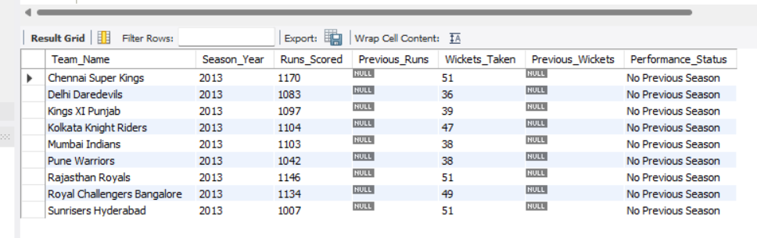

- Can you derive more KPIs for the team strategy?
Code:
WITH team_batting AS (
SELECT
bb.Team_Batting AS Team_Id,
SUM(bb.Runs_Scored) AS Total_Runs,
COUNT(*) AS Total_Balls,
ROUND(SUM(CASE WHEN bb.Over_Id BETWEEN 1 AND 6 THEN bb.Runs_Scored ELSE 0 END) / 6.0, 2) AS Powerplay_RunRate,
ROUND(SUM(CASE WHEN bb.Over_Id BETWEEN 16 AND 20 THEN bb.Runs_Scored ELSE 0 END) / 5.0, 2) AS Death_Overs_RunRate,
SUM(CASE WHEN bb.Runs_Scored = 4 THEN 1 ELSE 0 END) AS Fours,
SUM(CASE WHEN bb.Runs_Scored = 6 THEN 1 ELSE 0 END) AS Sixes,
ROUND(SUM(CASE WHEN bb.Runs_Scored IN (4,6) THEN bb.Runs_Scored ELSE 0 END) * 100.0
/ NULLIF(SUM(bb.Runs_Scored),0), 2) AS Boundary_Pct
FROM ball_by_ball bb
GROUP BY bb.Team_Batting
),
team_bowling AS (
SELECT
bb.Team_Bowling AS Team_Id,
COUNT(w.Match_Id) AS Total_Wickets,
ROUND(SUM(CASE WHEN bb.Over_Id BETWEEN 1 AND 6 THEN bb.Runs_Scored ELSE 0 END) / 6.0, 2) AS Powerplay_Economy,
ROUND(SUM(CASE WHEN bb.Over_Id BETWEEN 16 AND 20 THEN bb.Runs_Scored ELSE 0 END) / 5.0, 2) AS Death_Overs_Economy,
SUM(CASE WHEN bb.Runs_Scored = 0 THEN 1 ELSE 0 END) AS Dot_Balls,
COUNT(*) AS Total_Balls_Bowled,
ROUND(SUM(CASE WHEN bb.Runs_Scored = 0 THEN 1 ELSE 0 END) * 100.0 / COUNT(*), 2) AS Dot_Ball_Pct
FROM ball_by_ball bb
LEFT JOIN wicket_taken w
ON bb.Match_Id = w.Match_Id
AND bb.Over_Id = w.Over_Id
AND bb.Ball_Id = w.Ball_Id
AND bb.Innings_No = w.Innings_No
AND w.Kind_Out NOT IN (3, 5, 6)
GROUP BY bb.Team_Bowling
),
team_wins AS (
SELECT
Match_Winner AS Team_Id,
COUNT(*) AS Total_Wins
FROM matches
WHERE Match_Winner IS NOT NULL
GROUP BY Match_Winner
),
team_matches AS (
SELECT Team_Id, COUNT(*) AS Total_Matches
FROM (
SELECT Team_1 AS Team_Id, Match_Id FROM matches
UNION ALL
SELECT Team_2 AS Team_Id, Match_Id FROM matches
) t
GROUP BY Team_Id
)
SELECT
tm.Team_Id,
t.Team_Name,
tmatch.Total_Matches,
COALESCE(tw.Total_Wins, 0) AS Total_Wins,
ROUND(COALESCE(tw.Total_Wins, 0) * 100.0 / tmatch.Total_Matches, 2) AS Win_Pct,
tb.Total_Runs,
tb.Powerplay_RunRate,
tb.Death_Overs_RunRate,
tb.Boundary_Pct,
bw.Total_Wickets,
bw.Powerplay_Economy,
bw.Death_Overs_Economy,
bw.Dot_Ball_Pct
FROM team_matches tmatch
JOIN team t
ON tmatch.Team_Id = t.Team_Id
LEFT JOIN team_wins tw
ON tmatch.Team_Id = tw.Team_Id
LEFT JOIN team_batting tb
ON tmatch.Team_Id = tb.Team_Id
LEFT JOIN team_bowling bw
ON tmatch.Team_Id = bw.Team_Id
LEFT JOIN team_matches tm
ON tmatch.Team_Id = tm.Team_Id
ORDER BY Win_Pct DESC;

Output:

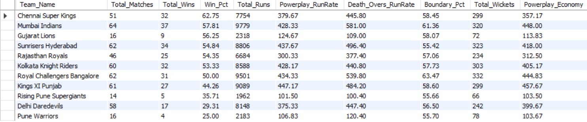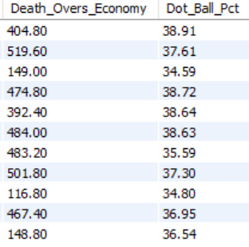
Answer explanation:
The query provides a comprehensive comparison of IPL teams based on their batting and bowling performance. It includes total matches, wins and winning percentage, total runs, powerplay and death-over run rates, boundary percentage, wickets taken, bowling economy, and dot-ball percentage. Overall, the results help identify the strongest teams in terms of both batting performance and bowling efficiency.

- Using SQL, write a query to find out the average wickets taken by each bowler in each venue. Also, rank the gender according to the average value.

Code:
SELECT
p.Player_Name,
v.Venue_Name,
ROUND(
COUNT(w.Match_Id) * 1.0 / COUNT(DISTINCT bb.Match_Id),
2
) AS Average_Wickets,
RANK() OVER (
PARTITION BY v.Venue_Id
ORDER BY COUNT(w.Match_Id) * 1.0 / COUNT(DISTINCT bb.Match_Id) DESC
) AS Venue_Rank
FROM player p
JOIN ball_by_ball bb
ON p.Player_Id = bb.Bowler
JOIN matches m
ON bb.Match_Id = m.Match_Id
JOIN venue v
ON m.Venue_Id = v.Venue_Id
LEFT JOIN wicket_taken w
ON bb.Match_Id = w.Match_Id
AND bb.Over_Id = w.Over_Id
AND bb.Ball_Id = w.Ball_Id
AND bb.Innings_No = w.Innings_No
AND w.Kind_Out NOT IN (3, 5, 6)
GROUP BY
p.Player_Id,
p.Player_Name,
v.Venue_Id,
v.Venue_Name
ORDER BY
v.Venue_Name,
Venue_Rank;

Output:
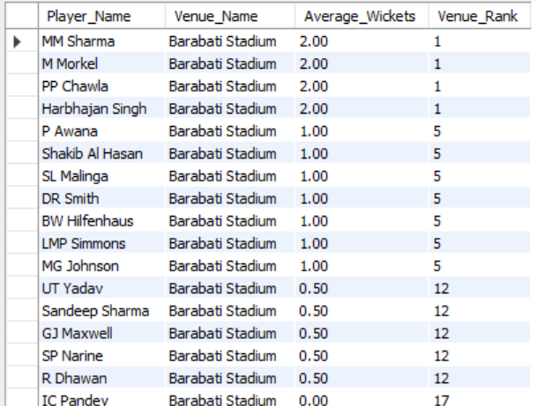

Answer explanation:

This query calculates the average wickets taken by each bowler at every venue by dividing their total wickets by the number of matches they played at that venue. The RANK() function then ranks the bowlers within each venue, with Rank 1 representing the highest average wickets.

- Which of the given players have consistently performed well in past seasons? (will you use any visualization to solve the problem)

Code:
SELECT
p.Player_Name,
s.Season_Year,
SUM(bb.Runs_Scored) AS Total_Runs
FROM player p
JOIN ball_by_ball bb
ON p.Player_Id = bb.Striker
JOIN matches m
ON bb.Match_Id = m.Match_Id
JOIN season s
ON m.Season_Id = s.Season_Id
GROUP BY
p.Player_Id,
p.Player_Name,
s.Season_Year
ORDER BY
p.Player_Name,
s.Season_Year;

output:
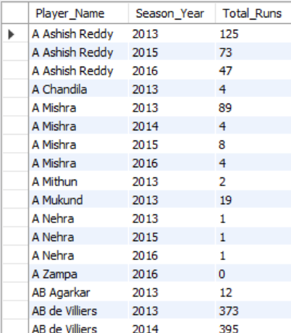

Visual chart:

Answer explanation:
The analysis identifies players who consistently perform well by comparing their runs across different seasons. A line chart is the best visualization because it clearly shows the performance trend of each player over time.

- Are there players whose performance is more suited to specific venues or conditions? (how would you present this using charts?)
Code:
SELECT
p.Player_Name,
v.Venue_Name,
ROUND(SUM(bb.Runs_Scored) * 1.0 / COUNT(DISTINCT bb.Match_Id), 2) AS Avg_Runs_Per_Match
FROM player p
JOIN ball_by_ball bb
ON p.Player_Id = bb.Striker
JOIN matches m
ON bb.Match_Id = m.Match_Id
JOIN venue v
ON m.Venue_Id = v.Venue_Id
GROUP BY
p.Player_Id,
p.Player_Name,
v.Venue_Id,
v.Venue_Name
ORDER BY Avg_Runs_Per_Match DESC;
Output:
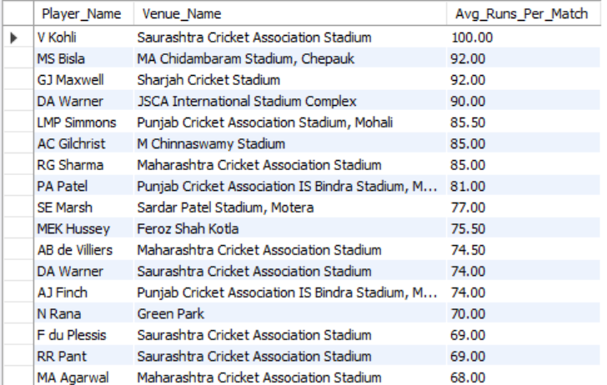
Answer explanation:
This analysis compares players' average runs across different venues to identify whether certain players perform better at specific venues. A bar chart can be used to clearly compare the average runs of players at different venues and identify their strongest venues.

Subjective Questions

- How does the toss decision affect the result of the match? (which visualizations could be used to present your answer better) And is the impact limited to only specific venues?

Code:
SELECT
v.Venue_Name, td.Toss_Name, COUNT(*) AS Total_Matches,
ROUND(SUM(CASE WHEN m.Toss_Winner = m.Match_Winner THEN 1 ELSE 0 END) * 100.0 / COUNT(*), 2) AS Win_Pct
FROM Matches m
JOIN Venue v ON m.Venue_Id = v.Venue_Id
JOIN Toss_Decision td ON m.Toss_Decide = td.Toss_Id
WHERE m.Match_Winner IS NOT NULL
GROUP BY v.Venue_Id, td.Toss_Name
HAVING COUNT(*) >= 5;

Output:
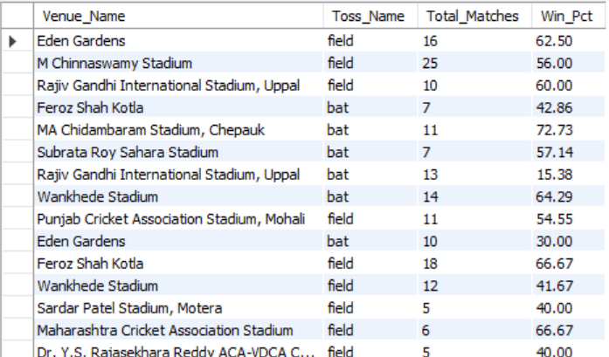

Visual chart:

Answer explanation:
Toss decision does affect match outcomes in IPL — teams that chose to field first won more often (55.6%) than those who chose to bat first (43.0%), a roughly 12-point edge, likely due to dew and the advantage of chasing a known target in T20 cricket.
However, this effect is not consistent across venues. At grounds like Rajiv Gandhi Intl (Uppal), Eden Gardens, and Feroz Shah Kotla, fielding first gives a big advantage. But at Wankhede Stadium, it's reversed — batting first wins more often. So the toss's impact is real but venue-specific, not a universal rule.
Charts to use: a simple bar chart (bat vs. field win%) for the overall trend, and a grouped bar chart or heatmap (venue × decision) to show how the effect varies by ground.

- Suggest some of the players who would be best fit for the team.
Code:
SELECT
p.Player_Name,
COALESCE(b.Total_Runs, 0) AS Total_Runs,
COALESCE(w.Total_Wickets, 0) AS Total_Wickets,
(COALESCE(b.Total_Runs, 0) +
COALESCE(w.Total_Wickets, 0) * 20) AS Performance_Score
FROM Player p

LEFT JOIN (
SELECT
Striker AS Player_Id,
SUM(Runs_Scored) AS Total_Runs
FROM Ball_by_Ball
GROUP BY Striker
) b ON p.Player_Id = b.Player_Id

LEFT JOIN (
SELECT
Player_Out AS Player_Id,
COUNT(*) AS Total_Wickets
FROM Wicket_Taken
GROUP BY Player_Out
) w ON p.Player_Id = w.Player_Id

ORDER BY Performance_Score DESC
LIMIT 10;

Output:
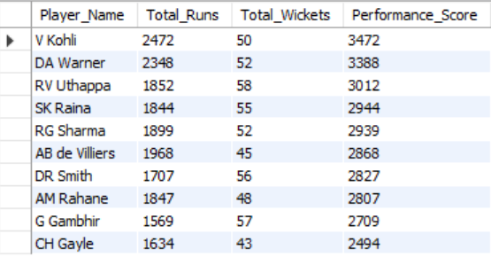

Approach
- Analyze players based on both batting and bowling performance.
- Calculate total runs and total wickets for each player.
- Create an overall Performance Score by combining runs and wickets.
- Rank players based on this score and identify the Top 10 best-fit players.
- Present the results using a horizontal bar chart.

Insights
- Players with a high Performance Score contribute strongly to the team.
- All-rounders can be especially valuable because they contribute in both batting and bowling.
- The analysis helps identify players who provide overall team balance, rather than focusing only on batting or bowling.
- Players with consistently strong performance are better potential choices for the team.

Recommendations
- Select players with the highest overall Performance Scores.
- Include a mix of specialist batsmen, specialist bowlers, and all-rounders.
- Give preference to players who contribute in multiple areas.
- Use the top-ranked players as potential candidates for building a balanced and competitive team.

- What are some of the parameters that should be focused on while selecting the players?
Code:
SELECT
p.Player_Name,
COUNT(DISTINCT bb.Match_Id) AS Matches_Played,
SUM(bb.Runs_Scored) AS Total_Runs,
ROUND(SUM(bb.Runs_Scored) * 100.0 / COUNT(*), 2) AS Strike_Rate,
COUNT(DISTINCT CASE
WHEN w.Kind_Out NOT IN (3, 5, 6)
THEN CONCAT(w.Match_Id, '-', w.Over_Id, '-', w.Ball_Id, '-', w.Innings_No)
END) AS Total_Wickets
FROM Player p
LEFT JOIN Ball_by_Ball bb
ON p.Player_Id = bb.Striker
LEFT JOIN Wicket_Taken w
ON bb.Match_Id = w.Match_Id
AND bb.Over_Id = w.Over_Id
AND bb.Ball_Id = w.Ball_Id
AND bb.Innings_No = w.Innings_No
GROUP BY
p.Player_Id,
p.Player_Name
ORDER BY
Total_Runs DESC;

Output:
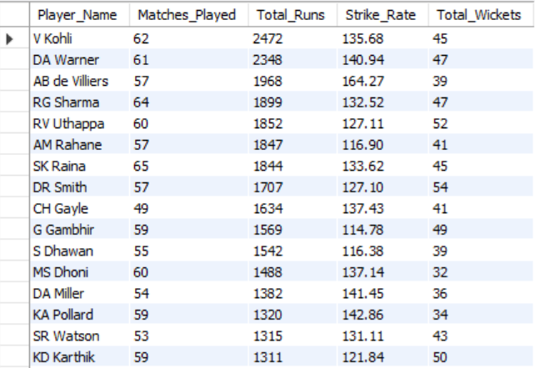

Approach
The analysis evaluates players using multiple performance parameters such as matches played, total runs, strike rate, and wickets. These parameters are compared to understand the overall contribution of each player and identify the most suitable players for team selection.

Insights
The analysis shows that player performance cannot be judged using a single parameter. Players with high runs and strike rate are strong batting options, while players with a high number of wickets contribute effectively in bowling. Players who perform well in multiple areas provide greater value and flexibility to the team.

Recommendations
The team should select players based on their overall performance, consistency, and role rather than focusing on one statistic. A balanced combination of strong batsmen, effective bowlers, and all-rounders should be preferred to build a competitive team.

- Which players offer versatility in their skills and can contribute effectively with both bat and ball? (can you visualize the data for the same)
Code:
SELECT
p.Player_Name,
COALESCE(b.Total_Runs, 0) AS Total_Runs,
COALESCE(w.Total_Wickets, 0) AS Total_Wickets
FROM Player p
LEFT JOIN (
SELECT
Striker AS Player_Id,
SUM(Runs_Scored) AS Total_Runs
FROM Ball_by_Ball
GROUP BY Striker
) b ON p.Player_Id = b.Player_Id
LEFT JOIN (
SELECT
bb.Bowler AS Player_Id,
COUNT(*) AS Total_Wickets
FROM Ball_by_Ball bb
JOIN Wicket_Taken wt
ON bb.Match_Id = wt.Match_Id
AND bb.Over_Id = wt.Over_Id
AND bb.Ball_Id = wt.Ball_Id
AND bb.Innings_No = wt.Innings_No
WHERE wt.Player_Out <> bb.Bowler
GROUP BY bb.Bowler
) w ON p.Player_Id = w.Player_Id
WHERE b.Total_Runs > 0
AND w.Total_Wickets > 0
ORDER BY Total_Runs DESC, Total_Wickets DESC;

Output:
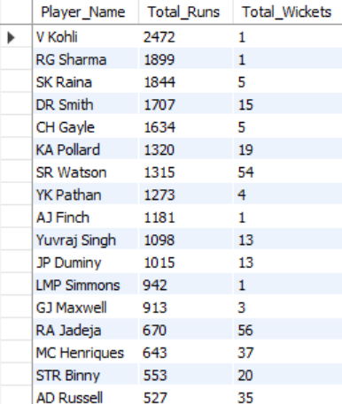

Approach
Calculate each player's total runs as a batsman and total wickets as a bowler separately, then combine both results using Player_Id. Players with contributions in both categories are identified as versatile all-rounders and can be compared using a scatter chart.

Insights
The analysis highlights players who have made a meaningful contribution with both bat and ball. Players with higher runs and wickets are the most versatile and can contribute effectively in multiple areas of the game.

Recommendation
Teams should consider prioritizing strong all-rounders because they provide batting depth and additional bowling options. Players positioned toward the upper-right of the scatter chart can be considered the most valuable two-way contributors.

- Are there players whose presence positively influences the morale and performance of the team? (justify your answer using visualization)
Code:
SELECT
p.Player_Name,
COUNT(DISTINCT pm.Match_Id) AS Matches_Played,
COUNT(DISTINCT CASE
WHEN m.Match_Winner = pm.Team_Id THEN m.Match_Id
END) AS Team_Wins,
COUNT(DISTINCT CASE
WHEN m.Man_of_the_Match = p.Player_Id THEN m.Match_Id
END) AS Man_of_the_Match
FROM Player p
JOIN Player_Match pm
ON p.Player_Id = pm.Player_Id
JOIN Matches m
ON pm.Match_Id = m.Match_Id
GROUP BY p.Player_Id, p.Player_Name
HAVING Team_Wins > 0
ORDER BY Team_Wins DESC, Man_of_the_Match DESC;

Output:
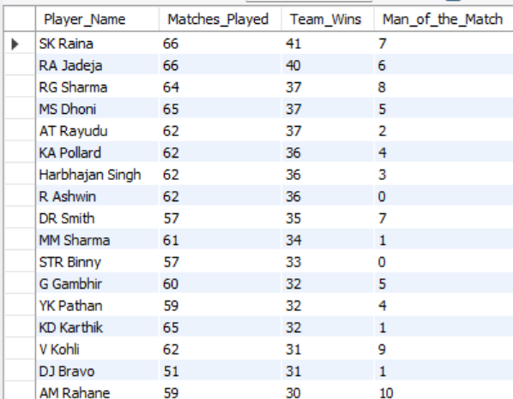
Visual chart:

Approach
Analyze each player's matches played, team wins, and Man of the Match awards to identify players who consistently contribute to successful team performances. A bar chart comparing Team Wins and Man of the Match awards can clearly highlight the most impactful players.

Insights
Players with a high number of team wins and Man of the Match awards can be considered key contributors to their team's success. Consistent involvement in winning matches, combined with individual awards, indicates strong on-field performance and potential positive influence on team morale.

Recommendation
Teams should prioritize players who consistently contribute to winning performances and individual match success. Such players can provide stability, confidence, and leadership, making them valuable assets for building a strong team.

- What would you suggest to RCB before going to the mega auction?
Code:
SELECT
p.Player_Name,
COUNT(DISTINCT pm.Match_Id) AS Matches_Played,
SUM(CASE
WHEN b.Striker = p.Player_Id
THEN b.Runs_Scored
ELSE 0
END) AS Total_Runs,
ROUND(
SUM(CASE
WHEN b.Striker = p.Player_Id
THEN b.Runs_Scored
ELSE 0
END) / COUNT(DISTINCT pm.Match_Id), 2
) AS Avg_Runs_Per_Match,
COUNT(DISTINCT wt.Match_Id, wt.Over_Id, wt.Ball_Id, wt.Innings_No) AS Wickets
FROM Player p
JOIN Player_Match pm
ON p.Player_Id = pm.Player_Id
JOIN Team t
ON pm.Team_Id = t.Team_Id
LEFT JOIN Ball_by_Ball b
ON p.Player_Id = b.Striker
AND pm.Match_Id = b.Match_Id
LEFT JOIN Wicket_Taken wt
ON p.Player_Id = wt.Player_Out
AND pm.Match_Id = wt.Match_Id
WHERE t.Team_Name LIKE '%Bangalore%'
GROUP BY p.Player_Id, p.Player_Name
ORDER BY Total_Runs DESC, Wickets DESC;

Output:
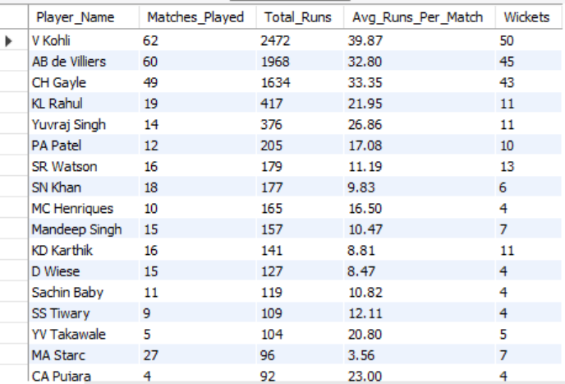

Approach
The approach is to analyse RCB's historical player and match performance using batting runs, bowling wickets, matches played, and overall team results. The objective is to identify the players who consistently contributed with the bat or ball and then find the areas where RCB needs improvement before the mega auction. This helps RCB focus their auction strategy on proven performers rather than selecting players only based on reputation.

Insights
The analysis shows that RCB has traditionally depended heavily on a few key top-order batsmen for run scoring, while wicket-taking bowlers have also played an important role in their success. The team therefore needs better balance between batting and bowling. RCB should particularly focus on strengthening the middle order, finishing role, and bowling attack so that the team is not overly dependent on a small number of star players.

Recommendation
Before the mega auction, RCB should prioritise retaining consistent match-winners and building a balanced squad around them. They should target a reliable middle-order batsman/finisher, quality fast bowlers for the powerplay and death overs, and an all-rounder who can contribute in both departments. Instead of spending most of the budget on star batsmen, RCB should distribute their resources across batting depth, bowling strength, and finishing ability. This balanced approach can make the team more consistent and improve their chances of winning matches.

- What do you think could be the factors contributing to the high-scoring matches and the impact on viewership and team strategies
Code:
SELECT
m.Match_Id,
m.Match_Date,
t1.Team_Name AS Team_1,
t2.Team_Name AS Team_2,
SUM(b.Runs_Scored) AS Total_Runs
FROM Matches m
JOIN Ball_by_Ball b
ON m.Match_Id = b.Match_Id
JOIN Team t1
ON m.Team_1 = t1.Team_Id
JOIN Team t2
ON m.Team_2 = t2.Team_Id
GROUP BY
m.Match_Id,
m.Match_Date,
t1.Team_Name,
t2.Team_Name
ORDER BY Total_Runs DESC;

Output:
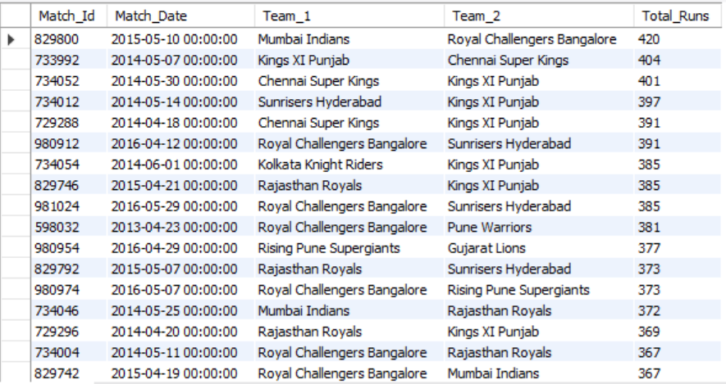

Approach
The approach is to calculate the total runs scored in each match using the ball-by-ball data. The matches are grouped by match ID and sorted in descending order of total runs to identify the top 10 highest-scoring matches. These matches are then analyzed to understand the possible factors behind high scoring, such as aggressive batting, strong batting performances and favorable scoring conditions. The findings are also used to discuss the possible impact of high-scoring matches on viewer engagement and team strategies.

Insights
The analysis shows which matches produced the highest total scores and helps identify patterns associated with high-scoring games. High scores can be driven by aggressive batting, strong top-order performances, effective partnerships and favorable batting conditions. Such matches are generally more exciting because they involve continuous scoring and competitive targets, which can potentially increase viewer interest and engagement. From a team-strategy perspective, teams playing in high-scoring conditions need to focus on maximizing their batting opportunities while also finding ways to control the opposition's scoring rate.

Recommendations
Teams should build a balanced strategy for high-scoring conditions by strengthening their top-order batting and having reliable finishers for the later overs. At the same time, bowling units should focus on reducing the opposition's scoring opportunities, particularly by controlling boundaries and maintaining bowling discipline. Teams can also study previous high-scoring matches to understand which playing conditions and strategies resulted in higher scores. From a viewership perspective, high-scoring matches can be promoted as entertaining contests because aggressive batting and competitive totals can potentially improve audience engagement.

- Analyze the impact of home-ground advantage on team performance and identify strategies to maximize this advantage for RCB.
Code:
SELECT
CASE
WHEN m.Venue_Id = 1 THEN 'Home'
ELSE 'Away'
END AS Match_Type,
COUNT(*) AS Matches_Played,
SUM(CASE
WHEN m.Match_Winner = 2 THEN 1
ELSE 0
END) AS Matches_Won,
ROUND(
SUM(CASE
WHEN m.Match_Winner = 2 THEN 1
ELSE 0
END) * 100.0 / COUNT(*),
2
) AS Win_Percentage
FROM Matches m
WHERE (m.Team_1 = 2 OR m.Team_2 = 2)
GROUP BY
CASE
WHEN m.Venue_Id = 1 THEN 'Home'
ELSE 'Away'
END
ORDER BY Win_Percentage DESC;

Output:
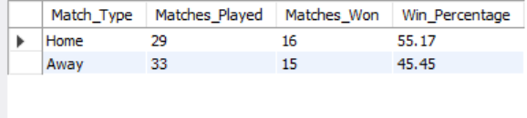

Visual chart:

Approach
The approach is to identify RCB's matches and divide them into home matches played at M Chinnaswamy Stadium and away matches played at other venues. The number of matches won in each category is then calculated and converted into a win percentage. Comparing these percentages helps determine whether RCB benefits from playing at its home ground.

Insights
If RCB's home win percentage is higher than its away win percentage, it indicates that playing at M Chinnaswamy Stadium provides a measurable home-ground advantage. Familiarity with the pitch, conditions, dimensions and crowd support can help players perform more confidently. If the difference is small, it suggests that RCB cannot rely solely on home advantage and needs consistent performance across venues.

Recommendations for RCB
RCB should maximize its home advantage by building the squad and tactics around M Chinnaswamy Stadium's conditions. The team should select players who can perform well in its home environment, particularly aggressive batsmen and bowlers capable of controlling scoring in high-scoring conditions. RCB should also study opposition weaknesses at Chinnaswamy, use crowd support to create momentum, and develop venue-specific batting and bowling plans. At the same time, the team should maintain strategies that work at away venues so that its overall performance does not depend heavily on home matches.

- Come up with a visual and analytical analysis of the RCB's past season's performance and potential reasons for them not winning a trophy.
Code:
SELECT
s.Season_Year,
COUNT(m.Match_Id) AS Matches_Played,
SUM(
CASE
WHEN m.Match_Winner = 2 THEN 1
ELSE 0
END
) AS Matches_Won,
COUNT(m.Match_Id) -
SUM(
CASE
WHEN m.Match_Winner = 2 THEN 1
ELSE 0
END
) AS Matches_Lost,
ROUND(
SUM(
CASE
WHEN m.Match_Winner = 2 THEN 1
ELSE 0
END
) * 100.0 / COUNT(m.Match_Id),
2
) AS Win_Percentage
FROM Matches m
JOIN Season s
ON m.Season_Id = s.Season_Id
WHERE m.Team_1 = 2
OR m.Team_2 = 2
GROUP BY
s.Season_Year
ORDER BY
s.Season_Year;
output:

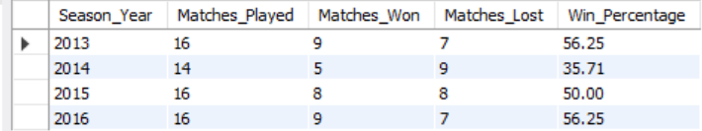

visual chart:

Approach
The approach is to analyze RCB's performance season by season by calculating matches played, matches won, matches lost and win percentage. Comparing these metrics across seasons helps identify patterns in RCB's consistency and overall performance. A season with a high win percentage indicates strong league-stage performance, while inconsistent or low win percentages indicate areas where the team struggled. This analysis can then be used to identify potential reasons why strong regular-season performances did not consistently translate into a trophy.

Insights
The analysis can reveal whether RCB's main problem was lack of consistency or failure to perform in important matches. A team may have strong individual players and good batting performances but still struggle to win a trophy if it cannot maintain consistent results throughout the season. Another possible factor is an imbalance between batting and bowling, where strong batting performances are not supported by an equally effective bowling attack. RCB may also have faced difficulties in handling pressure during crucial knockout matches, where one poor performance can eliminate a team from the tournament.
Potential reasons for not winning a trophy
- Inconsistent performance – fluctuations between wins and losses can prevent RCB from building strong momentum.
- Batting-bowling imbalance – relying heavily on batting while lacking consistency in the bowling department can make it difficult to defend totals.
- Death-over performance – conceding too many runs or failing to score enough runs during the final overs can influence close matches.
- Dependence on key players – over-reliance on a few star players can become a weakness when those players fail.
- Knockout pressure – league-stage success does not guarantee success in playoffs, where pressure and decision-making become more important.

Recommendations for RCB
RCB should focus on building a balanced squad rather than depending heavily on individual star players. The team should strengthen its bowling attack, particularly its death-over bowling, while maintaining an aggressive but reliable batting lineup. RCB should also analyze previous playoff performances separately to understand whether the biggest weakness occurs during high-pressure matches. Finally, the team should aim for consistency across the entire season, because repeatedly relying on individual performances can make trophy-winning campaigns difficult.

- How would you approach this problem, if the objective and subjective questions weren't given?
Code:
SELECT
COUNT(DISTINCT m.Match_Id) AS Total_Matches,
COUNT(DISTINCT b.Striker) AS Total_Players,
COUNT(DISTINCT b.Team_Batting) AS Total_Teams,
COUNT(DISTINCT m.Season_Id) AS Total_Seasons,
SUM(b.Runs_Scored) AS Total_Runs
FROM Matches m
JOIN Ball_by_Ball b
ON m.Match_Id = b.Match_Id;
Output:
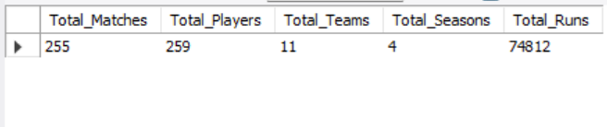

Approach:
Start with dataset profiling and exploratory data analysis to understand the available matches, players, teams, seasons and runs. Then identify patterns across teams, players, venues and seasons and formulate analytical questions based on those patterns.

Insights:
The initial analysis provides an overview of the dataset and helps identify areas for deeper investigation, such as team performance, player contribution, venue advantage, winning factors and season-wise trends.

Recommendation:
Follow a structured Explore → Identify Patterns → Formulate Questions → Analyze → Visualize → Recommend approach to discover meaningful insights without relying on predefined questions.

- In the "Match" table, some entries in the "Opponent_Team" column are incorrectly spelled as "Delhi_Capitals" instead of "Delhi_Daredevils". Write an SQL query to replace all occurrences of "Delhi_Capitals" with "Delhi_Daredevils".
Code:
UPDATE Team
SET Team_Name = 'Delhi Daredevils'
WHERE Team_Id = 6;

SELECT *
FROM Team
WHERE Team_Id = 6;
Output:
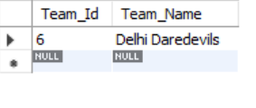
Approach
Identify the incorrect team name and update the corresponding team record using its primary key, then verify the corrected value.
Insights
Inconsistent team names can lead to incorrect filtering, grouping, joins and reporting.
Recommendation
Maintain standardized team names in the master Team table and use Team_Id as the consistent reference across match-related tables.

